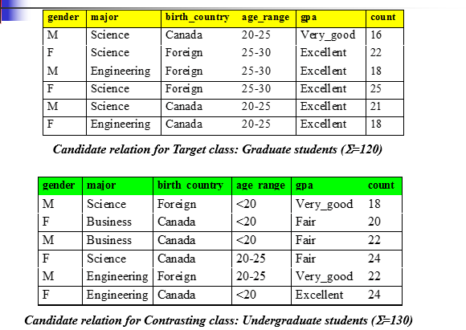

Calculate arbitrary tuple

$$I{(}s{1},s{2})=I{(}120,130)=-\frac{120}{250}\log{2}\frac{120}{250}-\frac{130}{250}\log{2}\frac{130}{250}=0.9988$$

Calculate entropy of each attribute:

**Major**

For major = Science $I{(}s{1},s{2})=I{(}84,42)=-\frac{84}{126}\log{2}\frac{84}{126}-\frac{42}{126}\log{2}\frac{42}{126}=0.9183$

For major = Engineering $I{(}s{3},s{4})=I{(}36,46)=-\frac{36}{82}\log{2}\frac{36}{82}-\frac{46}{82}\log{2}\frac{46}{82}=0.9892$

For major = Business $I{(}s{5},s{6})=I{(}0,22)=-\frac{0}{22}\log{2}\frac{0}{22}-\frac{22}{22}\log{2}\frac{22}{22}=0$

**Gender**

For gender = Female $I{(}s{1},s{2})=I{(}65,68)=-\frac{65}{133}\log{2}\frac{65}{133}-\frac{68}{133}\log{2}\frac{68}{133}=0.9996$

For gender = Male $I{(}s{3},s{4})=I{(}55,62)=-\frac{55}{117}\log{2}\frac{55}{117}-\frac{62}{117}\log{2}\frac{62}{117}=0.9974$

**Birth Country**

For birth country = Foreign $I{(}s{1},s{2})=I{(}65,40)=-\frac{65}{105}\log{2}\frac{65}{105}-\frac{40}{105}\log{2}\frac{40}{105}=0.9587$

For birth country = Canada $I{(}s{3},s{4})=I{(}55,90)=-\frac{55}{145}\log{2}\frac{55}{145}-\frac{90}{145}\log{2}\frac{90}{145}=0.9576$

**Age range**

For age range = <20 $I{(}s{1},s{2})=I{(}0,84)=-\frac{0}{84}\log{2}\frac{0}{84}-\frac{84}{84}\log{2}\frac{84}{84}=0$

For age range = 20 - 25 $I{(}s{3},s{4})=I{(}55,46)=-\frac{55}{101}\log{2}\frac{55}{101}-\frac{46}{101}\log{2}\frac{46}{101}=0.9943$

For age range = 26 - 30 $I{(}s{5},s{6})=I{(}65,0)=-\frac{65}{65}\log{2}\frac{65}{65}-\frac{0}{65}\log{2}\frac{0}{65}=0$

**Gpa**

For gpa = fair $I{(}s{1},s{2})=I{(}0,66)=-\frac{0}{66}\log{2}\frac{0}{66}-\frac{66}{66}\log{2}\frac{66}{66}=0$

For gpa = very good $I{(}s{3},s{4})=I{(}16,40)=-\frac{16}{56}\log{2}\frac{16}{56}-\frac{40}{56}\log{2}\frac{40}{56}=0.8631$

For gpa = excellent $I{(}s{5},s{6})=I{(}104,24)=-\frac{104}{128}\log{2}\frac{104}{128}-\frac{24}{128}\log{2}\frac{24}{128}=0.6962$

Calculate expected info if S is partitioned according to the attribute

$$E{(}\operatorname{major}{)}=\frac{126}{250}I(s11,s21)+\frac{82}{250}I(s12,s22)+\frac{42}{250}I(s13,s23)=0.7873$$

$$E{(}\operatorname{gender}{)}=\frac{133}{250}I(s11,s21)+\frac{117}{250}I(s12,s22)=0.9986$$

$$E{(}\operatorname{birth}{country)}=\frac{105}{250}I(s11,s21)+\frac{145}{250}I(s12,s22)=0.9581$$

$$E{(}age range{)}=\frac{84}{250}I(s11,s21)+\frac{101}{250}I(s12,s22)+\frac{65}{250}I(s13,s23)=0.4017$$

$$E{(}\operatorname{gpa}{)}=\frac{66}{250}I(s11,s21)+\frac{56}{250}I(s12,s22)+\frac{128}{250}I(s13,s23)=0.5498$$

Calculate information gain for each attribute

26-30

20-25

<20